Add cover Add comment

**Liquidity Pools**



**Reinforcing Liquidity Pools**

[WhE1n To Ant c1pat Ra d5]

**Liquidity** is the "open interest" of buyers and sellers in the market and can be further defined by those entities at or near specific price levels.

* **Buyers**

**Sellers**

**Buyers**

* **Sellers**

We want to sell to the buyers and buy from the sellers, sell at a premium and buy at a discount. Retail buys at premium and sells at discount.

If the market is bearish, we will be looking to sell above old highs

Theres going to be dumb buyers above highs or they have shorts on and there stop loss will be above that high a buy stop.

We want to sell in that pool of liquidity above an old high of buyers.

Were going to roleplay as in, ask yourself if i was short right now where would my buy stop be, and if i was long where would my sell stop be, by doing that we can get a view of where other traders have their buy and sell stops.

The trick is knowing want the underlying bias is of the market, does it want to go higher or lower on the HTF. Then it becomes easy to wait, if it wants to go higher wait for an old low to be taken out and we can be a buyer.

|  |  |  |
| --- | --- | --- |
| Liquidity Pool  **Profit Taken With Buy Stops Raided**  1111  \ 1,1111  1,1111,11  Oidl ,  Liquidity Pool Pnce Trades Lind.,. Old Low. Sel Stop Rlld |  | **Reinforcing Liquidity Pools** |
|  | **A.!7tic1pate Rads;** |
|  | **Run On Bullish Liquidity Pool:** |
|  | **Definition** - The Low that is Under the current market price action will typically have Trailed Sell Stops under it on Long Traders. Or Sell Stops for Traders who wish to Trade a Breakout Lower in Price for a Short Position. |
|  | **Validation:** When the Low is Violated or Price moves below the recent Low - the Sell Stops become Market Orders to Sell At Market. This injects Sell Side Liquidity into the Market - typically paired with Smart Money Buyers. |
| 1 | **Entry Techniques:** When underlying is Bullish. Before Price trades Under the recent Low - place a Buy Limit Order just below or at the recent Low. You are Buying the Sell Stops like a Bank Trader or any other "Smart Money" entity would. |
|  | **Defining Risk:** The Low you are Buying Under - can see a swing of 1O to 20 pips in most cases. **A** 30 to SO pip stop is ideal if your entry is Under the Low and not above it- fearing a missed entry. |
|  |  |  |

Expect a 10-20 pip sweep, if you instantly want to buy under the low then use a 30-50 pip stop loss. Don't FOMO by buying at the low or above it, buy under it.

If it starts moving beyond 25 pips its probably not a sweep and its likely a contuniuation of the decline

Accumulation sellside for longs and distributing the longs to buyside

,.,._

u,oe,.o,°""" 1,.m,1-n,susi11.uoo

,1·11j1I I

,,111' !'

-{, ...

·· U50CAO.MIJi.lMI.JlPl-ll41-""'

I.JIB

·-

u1•

·-

·-

r111 11

I tl1I 11

1.335,

11!11

,.

·-

··-

Ij !I

i

111 I.JIOJ

u, ..

I

!'!

L.JU5

**l<**

.·.-.

Ii.

1.lUCI

•=

··--

"

uu,

l1111l1tl'l+111l111111 **11** 1111

I

· ·

···--

,..

11 IH

•

*J..1.&,*

,m,

I.JIU

··

"*

"*

IH 1114

...

IIUI

·-

·-

,..

·-

,

..

·-

.

**l<**

T

Ive noticed ICT wait for a 15m sweep because the low before that on the 15m didnt sweep anything?

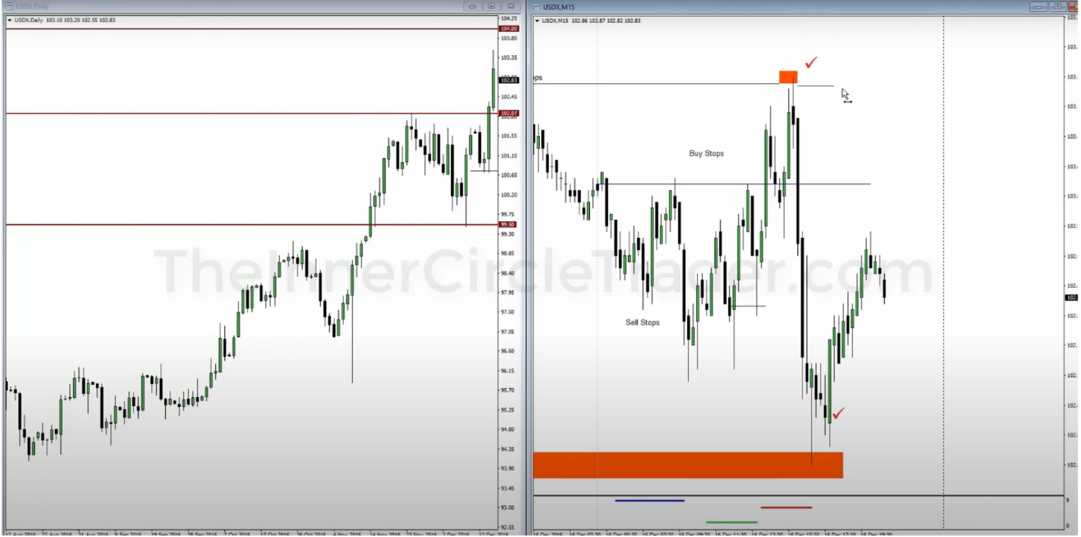

If the market has been trending troughout the week, the market will likely see a choppy day on friday because they want to take profit

0

* **.HII.NMUft!Ull'luotl.**
* _, ..IJ **1.JONU.,I 1-l"'11,_**

•

-

I

jllil!

1

111,1 ii'II

,111i 1j

**I**I

111111 :

I

!I**111**=**•:**

u,

,11

=

I

I

=

11,11,,11111

-lulli

11.250

-

··

-

•=

111111

•

=

11111,,1111,11

1'i111, i111 '111

**11!1**I**1** 111

=

111!

Iii

Ill,

1,,,, '

u•

'I

u

I **1,11'**

11

**Vl''1il''**

=

u•

111.1,1111

·-

u•

·-

•=

**l**

**:**

-

-

..

-

--

··--

u -

-

·-

u

u

w

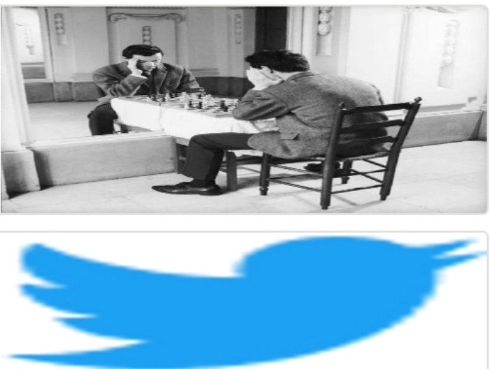Arjo I Twitter, lnstagram I Linktree

Linktree. Make your link do more. https://t.co/HhmmTN1fUI

JavaScript is not available.

***"JI*** https:1/twitter.com/arjoio